The APEC Photo Contest will take place again this year, and submissions are now open.

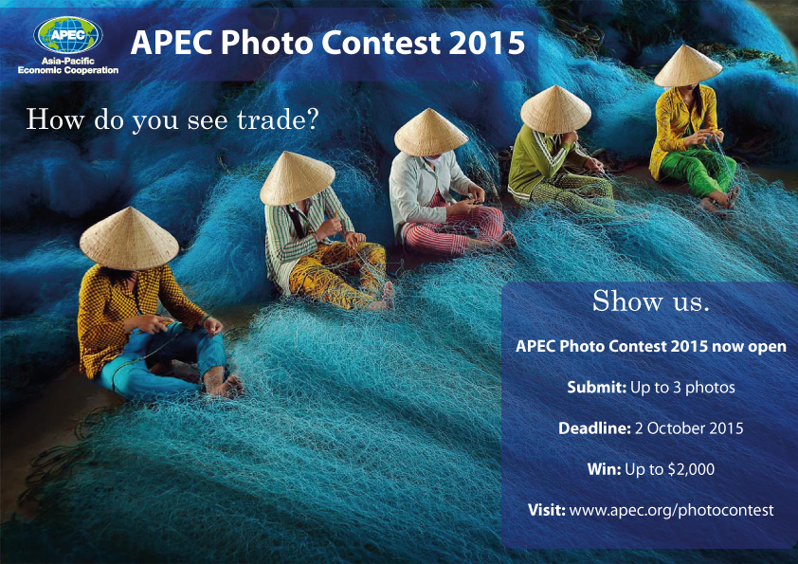
WHAT IS THE APEC PHOTO CONTEST 2015 ALL ABOUT?
The dynamic economies of the Asia-Pacific are made up of the livelihoods of people across the region. Through promoting trade and investment, APEC seeks to enhance the well-being and prosperity of all members of the Asia-Pacific. The APEC Photo Contest 2015 invites you to capture, through a photograph, how trade is reflected in your life and in the daily lives of people around the region.
This year’s contest asks participants to share photos that communicate how trade impacts our lives based on the following themes set by APEC’s host in 2015, the Philippines:
- Fostering small and medium enterprises (SMEs)’ participation in regional and global markets
- Investing in human capital development
- Building sustainable and resilient communities.
For more information, please visit the Photo Contest website where you can submit your photos online.
You may submit up to three photos via the APEC website online submission portal by Friday 2 October 2015. The first prize winner will receive SG$2,000, while second and third prize winners will receive SG$1,500 and SG$1,000 respectively.
The winners will also have the opportunity for his or her photo(s) to be showcased in APEC publications. In addition, on 12 October 2015, the top 10 photos will be published on APEC’s Facebook page for public voting through to 1 November 2015. The photo with the highest number of votes will win the Popular Choice Award and a prize of SG$1,000. Please follow us on Facebook, and Twitter to receive the latest updates.
We look forward to receiving your creative work!

