The Indonesian Ministry of Foreign Affairs |  | 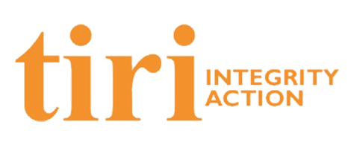

Call for Papers, Case Studies and Course Descriptions

ASEAN Conference
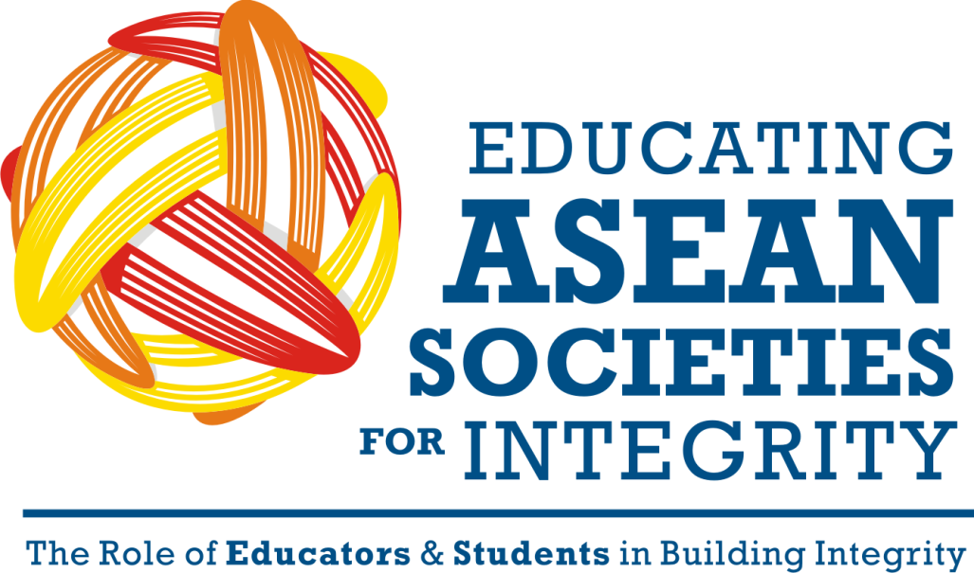

Jakarta – Indonesia
2 – 3 April 2013

Important Dates  Deadline for Receipt of Abstracts: 9 February 2013  Acceptance notification: 15 February 2013  Deadline for Paper submission: 5 March 2013 | Online Submission & further information:  integrityASEAN@gmail.com
 | www.ASEAN.indonesiaintegrity.net

Organizing Committee:
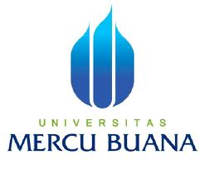
The Ministry of Foreign Affairs of the Republic of Indonesia and Tiri – Integrity Action, will be hosting an ASEAN Conference on 2-3 April 2013 in Jakarta, Indonesia on the theme of “Educating ASEAN Societies for Integrity: The Role of Educators and Students in Building Integrity”. The aim of this conference is to introduce and share different integrity building and anti-corruption education and the role than universities can play in this process. Although their approaches to teaching and learning may vary from country to country, the integrity educators share a common vision of empowering future professionals and public leaders to lead, manage, and live with integrity when they graduate from university.

As the organizing committee, the Mercubuana University together with the Indonesia Integrity Education Network (I-IEN) cordially invites abstract submissions for the consideration for the ASEAN conference. We are seeking papers in these following categories: an academic paper, a case study, or an analytic course description. We very much hope that we can interest you to take part and to your eventual contribution to the success of this important ASEAN conference.

Conference Overview

High levels of corruption and the lack of integrity in organizational governance worldwide cause harm and waste on an epic scale. Public corruption is often defined as involving behavior on the part of officials in the public sector, whether politicians or civil servants, in which they improperly and unlawfully enrich themselves, or those associated with them, by the misuse of the public power entrusted to them. Ultimately, it is a problem that encompasses all society, not just public officials. We define organizational integrity as the set of characteristics that improves trustworthiness to stakeholders. We define integrity as a concept that requires the alignment of Accountability, “Enabling stakeholders to check that we do what we say we do”; Competence, “Doing it well”; Ethics, “Doing it with honour and public purpose”; and Corruption control, “Doing it without corruption”.

The fight against corruption may be effective when preventive, punitive, and educational measures are combined. Most will agree that education is central to preventing corruption. Integrity education for young people can help break the cycle of corruption, as today’s youth will be the potential leaders of tomorrow. Raising integrity standards is increasingly recognized as an effective tool to foster development and strengthen democratic governance. Organizational integrity here refers both to internal processes of control and value-driven reform as well as to the engagement of external stakeholders in the process and management of reform.

Integrity Education
Integrity education is introduced as a response to a domestic situation demanding transparency and accountability in both the public and private sectors. It meets a need for critical and strategic approaches to successfully reform institutions to improve levels of governance and integrity. The principles, which are also in line with global norms and experiences, need to be adapted to the local environment.

The Integrity Education Network (IEN) was created in 2004 on the belief that universities and professional training institutions are an essential part of any national integrity system. IEN is the world’s largest and fastest growing network of educators and universities who share a common vision of empowering future professionals and public leaders to manage, lead, and live with integrity when they graduate from university. It has grown to over 360 universities and integrity-focused NGOs in over 60 countries by 2012. Over 25,000 students receive integrity education annually as a direct result of network activities.

The Indonesia Integrity Education Network (IIEN), with 109 university members, has been working to develop, mainstream, and advocate Integrity and Anti- Corruption Education at universities since 2009. The highlight of these efforts was reached when the Directorate of Higher Education under the Ministry of Education and Culture launched the National Anti-Corruption Curriculum in early 2012. This launch excited educators promoting integrity education and they subsequently developed specific teaching modules to complement the national curriculum. For instance, IIEN has developed integrity modules on six specialized topics (Law, Religion, Business Ethics, Public Administration, Communications, and Health); it produces teaching materials (“Active Learning Methods for Integrity Teaching); and it has developed an online integrity e-learning and resource -- www.e-learning.net --).

ASEAN Integrity for Integration

Living in the same region and having similar challenges in reducing corruption, ASEAN member countries must search for effective ways of minimizing the region's problems. Looking back at the Asian financial crisis in 1997, we can see, for example, how state bankruptcy caused by mismanagement can easily spill over to other ASEAN countries. It had a domino effect that had a negative impact on regional stability and development.

In early 2007 at the 12th ASEAN Summit in Cebu, the Philippines, the leaders of ASEAN made a commitment to accelerate regional integration through the Cebu Declaration on the Acceleration of an ASEAN Community by 2015. The ASEAN Community was designed to comprise three pillars, which are political and security community, economic community, and socio-cultural community, that work closely to ensure durable peace, stability, and shared prosperity in the region. In the same year, at the 13th ASEAN Summit held in Singapore, ASEAN Leaders agreed to develop a blueprint to promote the establishment of an ASEAN Socio-Cultural Community (ASCC). The ASCC will address the region’s aspiration to lift the quality of life of its peoples through cooperative activities that are people-oriented, environmentally friendly, and geared towards the promotion of sustainable development. The establishment of the ASEAN Community, specifically ASCC, can be designed as an entry point of introducing Integrity Education. Even if the practice would vary in every country, as long as it reflects Integrity principles and values, that kind of effort will positively contribute to regional enhanced capacity in its human resources to prevent corruption and build national – and regional - integrity.

Along with the establishment of the ASEAN Community, to strengthen the existing network of cooperation among universities in ASEAN, the ASEAN Universities Network (AUN) was established to help “hasten the solidarity and development of a regional identity through the promotion of human resource development so as to further strengthen the existing network of leading universities and institutions of higher learning in the region”. Since universities are one of the keys to introduce Integrity Education, collaboration with universities might also positively impact on the theme of ASEAN Integrity for Integration.

The idea for this conference and the proposal to facilitate ASEAN regional cooperation on the theme of integrity education was endorsed at the 35th SEAMEO High Officials Meeting and 7th Senior Officer Meeting for Education in Bangkok, Thailand, on 27–30 November 2012. The proposal was brought to the agenda of these meetings by the Ministry of Education and Culture of the Republic of Indonesia and the Ministry of Foreign Affairs of the Republic of Indonesia.

Objectives
The main objectives of the conference are to:
- Increase ASEAN community awareness on integrity in many sectors
- Share strategies and challenges of implementing integrity and anti-corruption education in the participants’ countries.
- Build a common understanding on integrity issues among ASEAN countries.
- Initiate a network among educational institutions in ASEAN countries on these topics.

Outputs
The planned outputs of the conference are:
- Sharing experiences among educators through dialogue
- Developing some a understanding of some of the overarching themes and challenges in the region formulated through the conference
- Publication of the best papers
- A network of educators and educational institutions in ASEAN countries

Abstract and Paper Submission Guidelines

Participants targeted in this conference are academics from ASEAN countries. The organizers invite interdisciplinary educators from high level education and universities level to submit their abstracts by February 5th, 2013. Following completion of the review process, the authors of the most interesting abstracts will be invited to give a presentation at the conference in Jakarta. In order to be included in the conference proceedings, authors must submit their papers by March 15th, 2013.

Benefits for successful participants are:
- Participants will have the opportunity to present their paper in front of the forum;
- Participants will receive a Certificate of Participation
- The best papers will be collected and published into an e-book
- Free registration fee

List of Categories and Themes
Reviewers welcome three types of papers:
- Academics papers;
- Case study; or
- Teaching case study/ an analytical description of an integrity course

An academic paper, a case study, or a teaching case study/ analytic description of a course can be presented in one of the following fields and disciplines:
Topics | Categories | Example of questions
Law | Academic paper | - What are some of the major integrity challenges of the legal profession, law enforcement, or judicial institution in your country? How are these problems currently being addressed? How have they have been addressed historically? What lessons have been learned about what works and what doesn’t?  - How do the poor or weaker sections of the society experience the legal profession and the law? What are the integrity and corruption problems they may face when interacting with the legal profession or law enforcement? How are these problems being addressed?  - How does the private sector (domestic and foreign, large and small) experience the legal profession and the law? What are the integrity and corruption problems they may face when interacting with the legal profession or law enforcement? How are these problems being addressed?
 | Case study | - Give a detailed case study of an integrity/governance reform in this sector.  - Give a detailed case study of corruption or maladministration in this sector from your country.  - Give a practical application on how integrity building and anti-corruption principles are being enforced in this sector.
 | Teaching case study/ an analytical description of an integrity course | - How do you teach integrity and anti-corruption in this discipline? What are the key topics? What are the learning objectives of the case?  - Do you address these themes in the whole or part of a course you teach? Who is your audience? What teaching methods do you use? What cases do you teach? What are the affective, cognitive and behavioral learning objectives? How do the students respond to the course? How is it tested?  - Give a detailed case study of corruption or maladministration in this sector from your country. How do you teach it? What are the learning objectives of the case?
Religion | Academic paper | - How are the ethical values found in every major religion translated into professional and social integrity, e.g. in the traditions of Buddhism, Christianity, Hinduism, Islam? What are the challenges of translating of these values into social and institutional reality? What is the role of religious institutions in helping to foster integrity in society and the professions? How might they do this even better?  - How do religious institutions (e.g. those providing services in health, social services, or education) ensure that they operate to the highest standards of integrity and that they can serve as a model for other institutions? Do they demonstrate leadership in transparency and accountability? What does this mean in practice for religious institutions in your country? Have there been any recent integrity problems related to religious institutions?  - To what extent does the relationship between the state and religious institutions affect the integrity of either set of institutions?
 | Case study | - Give a detailed case study of how the values of integrity implemented in social relations in the society.  - Give a detailed case study on the role of religious institutions in maintaining the values of integrity in the society.  - Give a practical application on how integrity building and anti-corruption principles are being enforced in this sector.
 | Teaching case study/ an analytical description of an integrity course | - How do you teach integrity and anti-corruption in this subject? What are the key topics? What are the learning objectives of the case?  - Do you address these themes in the whole or part of a course you teach? Who is your audience? What teaching methods do you use? What cases do you teach? What are the affective, cognitive and behavioral learning objectives? How do the students respond to the course? How is it tested?  - Give a detailed case study of an integrity/governance reform in this sector. How do you teach it? What are the learning objectives of the case?  - Give a detailed case study of corruption or maladministration in this sector from your country. How do you teach it? What are the learning objectives of the case?
Health | Academic paper | - What are the integrity problems related to the health sector in your country? How are these being addressed? How have they been addressed historically? Have any lessons been learned? How transparent or accountable are these institutions?  - Can different sets of integrity problems be found in private as opposed to public health care facilities? What are they? Who is responsible for addressing them, and what is being done to address these challenges?  - How do religious institutions (e.g. those providing services in health, social services, or education) ensure that they operate to the highest standards of integrity and that they can serve as a model for other institutions? Do they demonstrate leadership in transparency and accountability? What does this mean in practice for religious institutions in your country? Have there been any recent integrity problems related to religious institutions?  - To what extent does the relationship between the state and religious institutions affect the integrity of either set of institutions?
 | Case study | - Give a detailed case study of an integrity/governance reform in this sector.  - Give a detailed case study of corruption or maladministration in this sector from your country.  - Give a practical application on how integrity building and anti-corruption principles are being enforced in this sector.
 | Teaching case study/ an analytical description of an integrity course | - How do you teach integrity and anti-corruption in this subject? What are the key topics? What are the learning objectives of the case?  - Do you address these themes in the whole or part of a course you teach? Who is your audience? What teaching methods do you use? What cases do you teach? What are the affective, cognitive and behavioral learning objectives? How do the students respond to the course? How is it tested?  - Give a detailed case study of an integrity/governance reform in this sector. How do you teach it? What are the learning objectives of the case?  - Give a detailed case study of corruption or maladministration in this sector from your country. How do you teach it? What are the learning objectives of the case?
Public Administration | Academic paper | - Focus on one of the major integrity problems in the public administration in your country, for example around public procurement, around human resource management: How are these being addressed? How have they been addressed historically? Have any lessons been learned?  - How do the poor and weaker sections of society experience the public administration? What are they most satisfied with? What are they least satisfied with? To what extent are the issues related to integrity (accountability/transparency, competence, ethics, corruption) related to the problems people experience?  - What is the role in your country of the community and regular citizens monitoring the performance of the public administration? How is this being received? Is it contributing to any improvements in the performance of the public administration? Is it contributing to improving relations between the public administration and the public?
 | Case study | - Give a detailed case study of an integrity/governance reform in this sector.  - Give a detailed case study of corruption or maladministration in this sector from your country.  Give a practical application on how integrity building and anti-corruption principles are being enforced in this sector.
 | Teaching case study/ an analytical description of an integrity course | - How do you teach integrity and anti-corruption in this subject? What are the key topics? What are the learning objectives of the case?  - Do you address these themes in the whole or part of a course you teach? Who is your audience? What teaching methods do you use? What cases do you teach? What are the affective, cognitive and behavioral learning objectives? How do the students respond to the course? How is it tested?  - Give a detailed case study of an integrity/governance reform in this sector. How do you teach it? What are the learning objectives of the case?  - Give a detailed case study of corruption or maladministration in this sector from your country. How do you teach it? What are the learning objectives of the case?
Business | Academic paper | - What are the major integrity challenges facing Small, Medium Enterprises (SMEs) in your country? Do they face specific integrity challenges as they try to grow into a bigger business?  - What are the role models for business integrity among large companies in your country? What makes them role models? Is it possible to compare two or more role model companies to draw lessons on the principles behind business integrity in your country?  - Does corruption and maladministration constitute a barrier to entry for foreign companies in your country? How is this being addressed? What reforms are being encouraged and promoted? Who is promoting these reforms?  - What are the major challenges of regulation and enforcement of business integrity in your country? How are these challenges being addressed? How effective is regulation and enforcement? What explains the strengths and weaknesses?
 | Case study | - Give a detailed case study of an integrity/governance reform in this sector.  - Give a detailed case study of corruption or maladministration in this sector from your country.  - Give a practical application on how integrity building and anti-corruption principles are being enforced in this sector.
 | Teaching case study/ an analytical description of an integrity course | - How do you teach integrity and anti-corruption in this subject? What are the key topics? What are the learning objectives of the case?  - Do you address these themes in the whole or part of a course you teach? Who is your audience? What teaching methods do you use? What cases do you teach? What are the affective, cognitive and behavioral learning objectives? How do the students respond to the course? How is it tested?  - Give a detailed case study of an integrity/governance reform in this sector. How do you teach it? What are the learning objectives of the case?  - Give a detailed case study of corruption or maladministration in this sector from your country. How do you teach it? What are the learning objectives of the case?
Communication | Academic paper | - What are the major integrity challenges facing communications professionals and organizations (e.g. media, public relations, advertising, etc.) in your country?  - What are the challenges of regulation and enforcement on integrity issues, especially related to new media in your country?
 | Case study | - Give a detailed case study of an integrity/governance reform in this sector.  - Give a detailed case study of corruption or maladministration in this sector from your country.  - Give a practical application on how integrity building and anti-corruption principles are being enforced in this sector.
 | Teaching case study/ an analytical description of an integrity course | - How do you teach integrity and anti-corruption in this subject? What are the key topics? What are the learning objectives of the case?  - Do you address these themes in the whole or part of a course you teach? Who is your audience? What teaching methods do you use? What cases do you teach? What are the affective, cognitive and behavioral learning objectives? How do the students respond to the course? How is it tested?  - Give a detailed case study of an integrity/governance reform in this sector. How do you teach it? What are the learning objectives of the case?  - Give a detailed case study of corruption or maladministration in this sector from your country. How do you teach it? What are the learning objectives of the case?

Abstracts in these areas are particularly encouraged for submission to the ASEAN Conference “Educating ASEAN Societies for Integrity: The Role of Educators and Students in Building Integrity”. Topics are not exclusive and findings or programmatic efforts as long as related with any integrity building and anti-corruption, are eligible for submission.

Instructions for Submitting an Abstract

- File format. All abstracts submitted must be in .doc, .docx or .rtf format. They must be single-spaced page with no headers or footers (except for pagination) and use the Arial 11 point font. They may not exceed the maximum limit of 250 words. Please include a minimum of 3 keywords.
- Method of submission. All abstracts must be submitted by February 9th, 2013. This deadline will be strictly enforced. All abstracts are to be submitted electronically via email integrityASEAN@gmail.com
- Language. All abstracts submission for review must be in English.
- Topics. Choose a category from the list provided below and select sub-theme that best reflects the content area of your abstract.
- Anonymity. Abstracts must be suitable for a blind review process. Contact information on the authors should be provided on a separate sheet. Please attach the personal detail form along with your abstract.
- Acknowledgment of Receipt of Abstracts Submitted. Upon submission of your abstract, you will receive an email message confirming that their abstracts have been received. Please note that if you do not receive an email message your abstract has not been entered into the database. Once an abstract is submitted, you cannot change the paper title. If accepted, the title will remain the same in the conference schedule and in the e-book.
- Author(s). No paper can have more than (5) five authors. If there is more than one author, authors must indicate which author will be most likely to present the paper at the conference. This information can be changed later.
- Number of submissions. Individuals may submit at most three (3) abstracts for review.
- Plan. Authors who submit an abstract for a paper should do so with the understanding that they plan to attend the ASEAN Conference “Educating ASEAN Societies for Integrity: The Role of Educators and Students in Building Integrity”. Participants are expected to cover their own travel costs (both flights and local transportation), except participants from Cambodia, Laos, and Myanmar. The organizers will provide free registration, three (3) nights’ accommodation, and meals during the conference.

Instructions for Submitting the Full Paper
- Method of Submission. All submissions must be sent as email attachments to integrityASEAN@gmail.com . The subject line of the email should be:
ASEAN Conference 2013 paper submission from [insert your name]
It will greatly facilitate the work of the program committee if you use this exact wording and replace the blank with your name.
- File Format. All files submitted must be in .doc, .docx or .rtf format. They must be double-spaced with no headers or footers (except for pagination) and use the Arial 11 point font. They may not exceed the maximum limit of 15 pages.
- Cover page format. The cover page should consist of the title, theme, name, institution, contact number, email address, abstract, and key words.
- Full paper format. For papers under academic and case study categories, the content should include the introduction, literature review, methodology, research result, conclusion, references, and appendices (if needed). While for the analytic course description category, the content should include an overview, main and subtopics, intended learning outcomes for the students, main analytical questions, teaching methods, and appendices including the English-version of the module (if possible).
- Body note. Use body note/run note citation: last name, publishing year, and page.
- Reference format. Use APA format for references: last name, first name (year of publication), title of the book. City, publisher.
- Biography. While submitting your paper, please send along a maximum 500 words biography with photograph of the author.

Important Deadlines
February 9, 2013 | Last day for submission of abstracts
February 15, 2013 | Author notification of paper abstracts accepted
March 15, 2013 | Deadline for submission of final paper

Other Technical Events and Information

Fees, Expenses, and Financial Assistance
Selected participants from Indonesia, Brunei Darussalam, Malaysia, the Republic of the Philippines the Republic of Singapore, the Kingdom of Thailand, and the Socialist Republic of Vietnam will be responsible for their own travel (both airfares and local transportation). The organizers will cover transportation costs for selected participants from the Kingdom of Cambodia, the Lao People’s Democratic Republic, and the Union of Myanmar.

The organizers will provide the conference registration fee for the 90 best qualified applicants. The conference registration fee includes the following: conference registration, accommodation for 3 nights, lunches during the two days conference, the Monday and Wednesday evening receptions and dinners.

Further information
For further information, please contact:
integrityasean@gmail.com
Sophie +62818416024
Nindyta +6282112931999

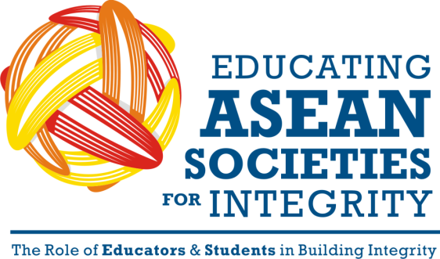 | Submission Form

Contact information for this application
The Main Author | Title
 | First name
 | Last name
University/ School
Address
 | City |  | Province
 | ZIP |  | Country
Contact information | Telephone |  | Fax
 | Cell-phone |  | Email
Affiliation
Co-Author (if any)

Tile of paper
Select the categories your paper is submitted for | - Academic papers  - Case studies  - Course descriptions
Select the theme your paper is submitted for | - Law  - Religion  - Health  - Public Administration  - Business  - Communications

Date: | Signature of the Applicant

213 in Europe and Central Asia, 109 in Indonesia, 32 in China, and 14 in the Arab World. Our individual scholars have grown to 980; 400 in China; 218 in Indonesia; 30 in Arab World and 350 in ECA and Africa

